2022-2023 Updated BIFE Guide for Learners and Applicants - Applying Online for a Course Using www.fetchcourses.ie

Before you begin, you will need:
your PPSN, your type of Social Welfare Payment (if relevant) and your Medical Card number (if relevant).

- Open your existing personal email in browser (e.g. gmail, yahoo...).

- Keep your email open and open a new tab in the browser and type in www.fetchcourses.ie

- If you are already registered on www.fetchcourses.ie, sign in with your email address and password then proceed to step 7.
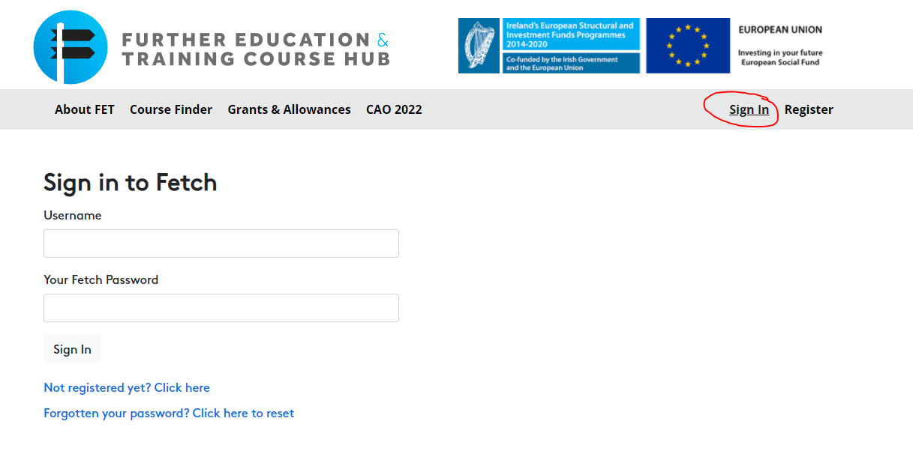

- If you are not yet registered on www.fetchcourses.ie, click ‘Register’.
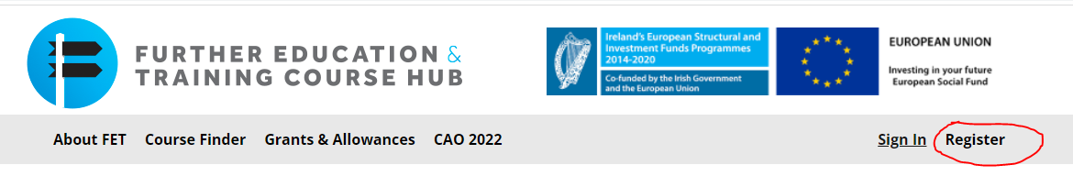
Fill in all required details, choose a password you will remember and keep it safe, read and accept Terms and Conditions and follow the instructions on the captcha. Click ‘Register’
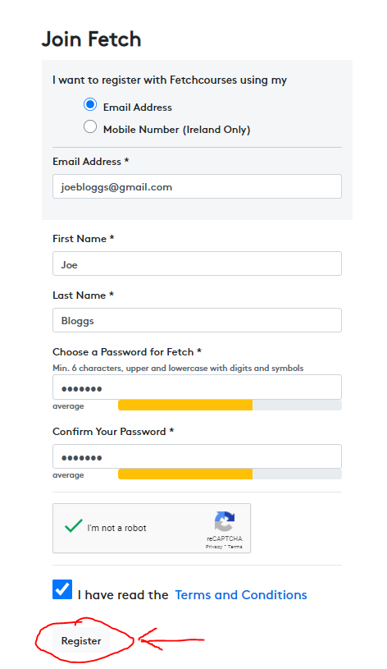

- You will then need to go to your email and click the link sent from ‘noreply-fetchcourses@solas.ie’ to confirm your email. If you cannot find the email, check in your ‘Clutter’ or ‘Other’ folder.
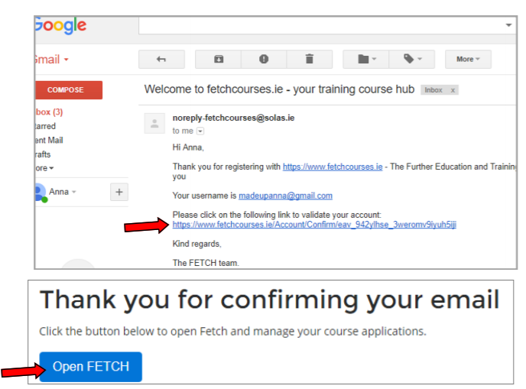

- This will bring you to your own Fetch dashboard/screen
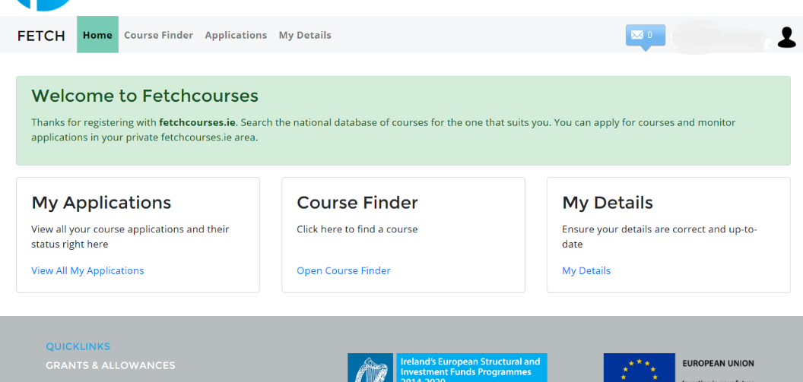

- Select My Details tab and click the Edit button, fill in all required information under all the tabs.
It is important to fill in your details in each tab - by clicking on ‘Social Welfare’, ‘Education’ and ‘My Status’. It is important to click ‘Save’ in each section before moving to the next.
The ‘Further Details’ will not be required until you start on the course, and it is optional to complete.
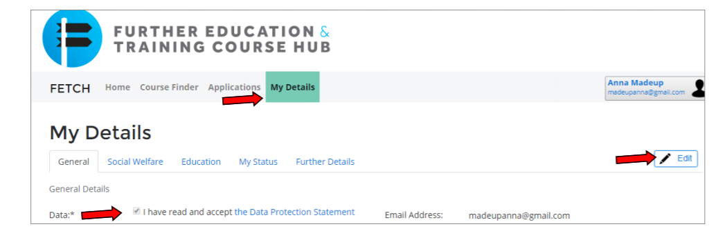

- Once the steps above are complete and you have saved your profile, Click the ‘Course Finder’ link shown below in FETCH to access the course finder
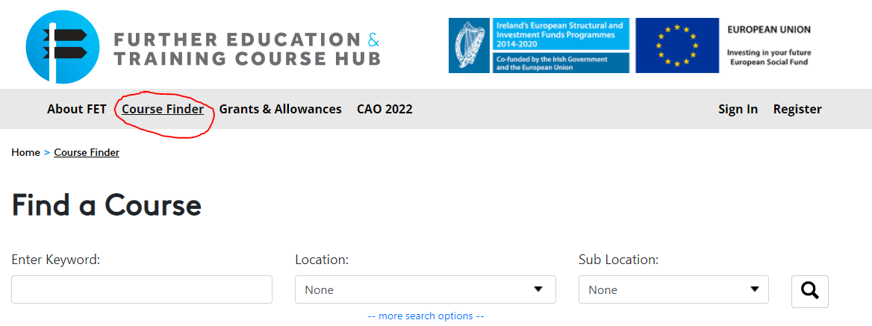

- Enter the course number provided by your coordinator in the ‘Enter Keyword” field and select the course

- Click the green Apply Now button as shown below.
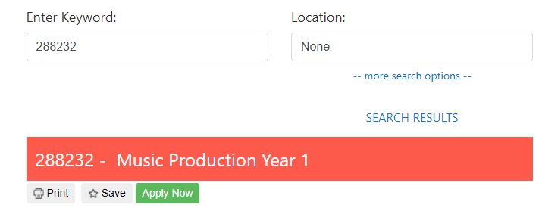

- Enter your details on the application form that opens (if not already auto-completed). You must Read and Accept the “Data Acknowledgement Statement” and then click the green Apply Now button.
- When completed sign out of Fetch account (top right-hand corner) and sign out of your email.
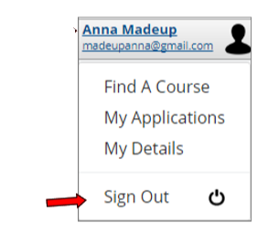

- Once the College/Centre has accepted and verified your application, you can check the status of your application online by logging into your Fetch account and clicking ‘View All My Applications’.

- You can log into www.fetchcourses.ie anytime in the future to update your details, apply for other courses or check the status of course applications.

